An Investigation of the Polymerase Chain Reaction

Course Instructor: Paul Kasili, Ph. D.

Performed by:

Due:Wednesday, February 13, 2013

**Objective:**

The polymerase chain reaction (PCR) is widely used within the field of genetics to create many copies of DNA from a small amount. Initially used to detect sickle cell anemia, it was developed by Kary Mullis in 1983, it has become a very important technique for its ability to amplify DNA. In an effort to refine our skills and understand PCR's mechanisms of action, we completed a typical Polymerase Chain Reaction (PCR) upon template DNA, and three primers in this study. This amplified DNA is then run across a porous agarose gel. While the procedure did not yield the anticipated bands of DNA, it demonstrated the need for well calibrated equipment and diligent technique to provide accurate results.

**Results:**

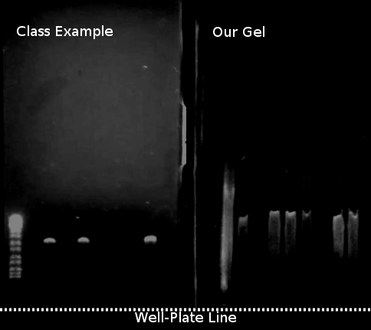

Figure : Agar Comparison

As shown on our gel, there was significant smearing, preventing any significant meaning to be gleaned from it.



Figure - DNA Ladder

When considering the provided example, the DNA primers were shown to be between the 7th and 8th markers, showing their number of kilobases to be approaching 2.0, or approximately 1900 bases.

**Discussion:**

As observed from the two well plates, ours was not properly performed. Research suggests that the streaking can be caused by a number of issues, either irregular voltage; a high temperature buffer solution; a degraded (old) primer; a low annealing temperature. Given that this occurred for the entirety of the class, it is my belief that the annealing temperature set on the Thermal Cycler was too low for this sample, but that would not account for the malformed ladder. The error was probably due to a low gel concentration. This would cause the primers to run too quickly, an issue which would cause the samples to smear as heavily as they did.

**Extra Credit:**

A negative sample could be created by making a sample without any template DNA. If it amplifies, then contamination is present, and the results would be discarded. It can simply be water in a well plate.